**BÁO CÁO OOP LAB 03**

**Họ tên: Trương Ngọc Mai – 20225879**

1. **Answer Question:**

* Question: Is JAVA a Pass-by-Value or a Pass by Reference programming language? Answer: Java is a Pass-by-Value programming language.
* Questions:
* After the call of swap(jungleDVD, cinderellaDVD) why does the title of these two objects still remain?
* After the call of changeTitle(jungleDVD, cinderellaDVD.getTitle()) why is the title of the JungleDVD changed?

Answer:

* When calling swap(jungleDVD, cinderellaDVD), Java created copies of the references. The swap only changes these copies inside the method, and the original in main() remains unchanged. Thus, after the method call, the jungleDVD still “Jungle” and the cinderellaDVD still “Cinderella”.
* The JungleDVD’s title changed because the line dvd.setTitle(title) changes the content of the object. Although dvd is just a copy of the reference, it still points to the same object in memory. So when we call the setTitle() method, we’re changing the data inside that object.

1. **Source code:**

* *addDigitalVideoDisc(DigitalVideoDisc [] dvdList)*

* *addDigitalVideoDisc(DigitalVideoDisc ….dvdarr)*

* *addDigitalVideoDisc(DigitalVideoDisc dvd1,DigitalVideoDisc dvd2)*

* **TestPassingParameter.java:**

* **Keep track of the number of DVDs created:**

* **printCart() method:**

* **CartTest.java**

* **Search for DVDs in the cart by ID and display the search results:**

* **Search for DVDs in the cart by title and print the results:**

* **Store.java:**

* **String, StringBuilder and StringBuffer:**

1. **ConcatenationInLoops.java:**

1. **GarbageCreator.java:**

1. **NoGarbage.java:**

1. **Code debugging and breakpoints**

**Ban đầu :**

**Swap:**

**Sau khi thực thi hàm swap:**

* **Title không có gì thay đổi.**

**Trước khi thực hiện changeTitle:**



**Step Over:**

**Sau khi thực hiện changeTitle:**



* **Tiêu đề đã thay đổi**

1. **Usecase Diagram and Class Diagram**

* **Usecase Diagram**

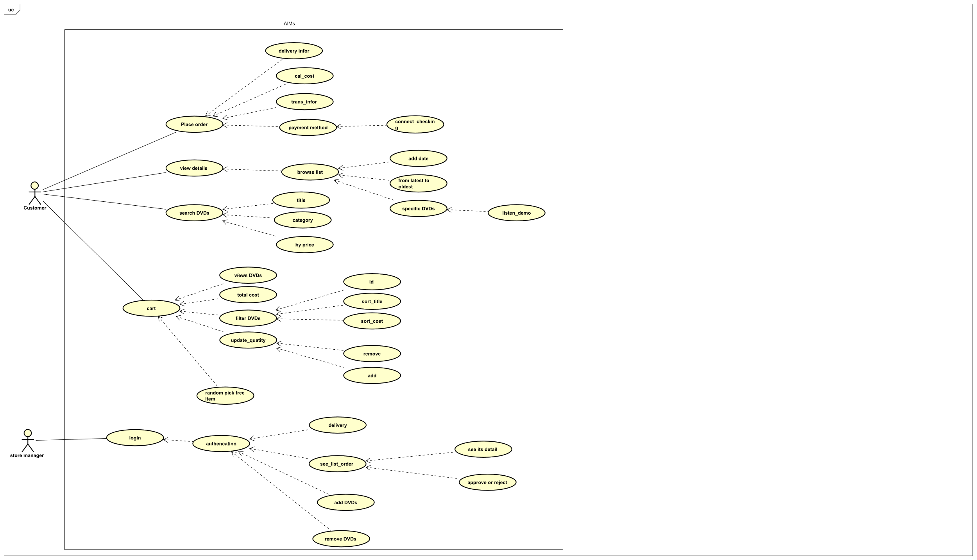

* **Class Diagram**

